The study of heat changes accompanying a chemical reaction is known as:
A. Electrochemistry
B. Physical chemistry
C. Thermochemistry
D. Biochemistry
ANSWER: C
The subject matter of thermochemistry is based on:
A. 1st law of thermodynamics
B. Law of conduction
C. 2nd law of thermodynamics
D. Newton’s second law of motion
ANSWER: A
Which one of the following is incorrect to the first law of thermodynamics?
A. Heat lost by system is equal to heat gained by surrounding and vice versa
B. Energy can neither be created nor destroyed through it can be changed from one form to another form
C. Energy of the universe tends to be constant
D. Energy of the universe tends to be either maximum or minimum
ANSWER: D
First law of the thermodynamics may be denoted under various conditions as
A. ∆H = ∆E if ∆n = 0
B. ∆H = q_{p} if ∆p = 0
C. ∆e = qv if ∆V = 0
D. All are correct
ANSWER: D
Which statement is contrary to the first law of thermodynamics?
A. Energy can neither be created nor destroyed
B. One form of energy can be converted into other form of energy
C. In an adiabatic process the work done is independent of its path
D. Continuous production of mechanical work without supplying an equivalent amount of heat is possible
ANSWER: D
The first law of thermodynamics is also called:
A. Law of motion
B. Law of conservation of mass
C. Law of conservation of energy
D. Gay-Lussac’s Law
ANSWER: C
The scope of thermochemistry is limited mainly because:
A. This field is not important
B. It has no advantage in daily lives
C. Few chemical reactions whose heat of reactions can be measured
D. Lack of funding
ANSWER: C
Thermodynamics does not deal with:
A. Heat of reaction
B. Rate of reaction
C. Spontaneity of reaction
D. Entropy of reaction
ANSWER: B
Which of the following statements does not correspond to the first law of thermodynamics?
A. Energy can neither be created nor destroyed
B. A system may lose energy but that energy will go to the surroundings to increase
C. The total energy of the system and its surroundings remains constant
D. All the above statements are correct
ANSWER: D
Mathematical form of first law of thermodynamics is:
A. $H=q×p$
B. $E=q+W$
C. $E=q×v$
D. All of the above
ANSWER: B
If q is the heat added to the system, w is the work done by the system and Delta is the change in internal energy, then according to the first law of thermodynamics:
A. $ΔE=q+w$
B. $ΔE=q–w$
C. $ΔE=q+PΔV$
D. $ΔE=q+ΔH$
ANSWER: B
Select the wrong statement:
A. First law of thermodynamics is also known as law of conservation of energy
B. The internal energy of an isolated system is constant
C. Both of the above
D. None of the above
ANSWER: D
Which of the following fundamental thermodynamics properties does not depend upon the state of the system only?
A. Work done
B. Internal energy
C. Enthalpy
D. None of the above
ANSWER: A
An example (nearest) of isolated system:
A. Man, Plant
B. Sealed tube containing hot water
C. A solution is sealed thermos flask
D. None of the above
ANSWER: C
Most of thermodynamic parameters are:
A. System
B. Surrounding
C. Phase
D. State functions
ANSWER: D

Internal energy is:
A. Not a state function
B. Sum of kinetic and potential energy
C. State function
D. Both a and c
ANSWER: D

Which statement is false regarding heat?
A. Heat is a state function
B. Symbol of heat is q
C. Heat is the property of a system
D. Sign of q is positive when heat is absorbed by the system from the surroundings
ANSWER: C

The total heat contents is called:
A. Internal energy
B. Pressure volume work
C. Enthalpy
D. Neutralization
ANSWER: C

Which statement is false regarding work?
A. Work is not a state function
B. Pressure-volume work is most commonly encountered in thermochemistry
C. W= F * S
D. Symbol of work is W
ANSWER: A

The enthalpy value of all elements at standard conditions is taken as:
A. Zero
B. Negative
C. Positive
D. None
ANSWER: A

The amount of heat evolved or absorbed by keeping reactants and products at constant atmospheric pressure at room temp is called:
A. Heat of formation
B. Standard heat of formation
C. Standard enthalpy change
D. None
ANSWER: D

Which statement is contrary to the first law of thermodynamics?
A. Energy can neither be created nor destroyed
B. One form of energy can be converted into other form of energy
C. In an adiabatic process the work done is independent of its path
D. Continuous production of mechanical work without supplying an equivalent amount of heat is possible
ANSWER: D

The work done by expansion of gas against constant pressure is:
A. P ∆ V
B. –P ∆ V
C. PV
D. ∆PV
ANSWER: A

Which statement is false regarding enthalpy?
A. Enthalpy is a state function
B. It is measured in joules
C. It is possible to measure the enthalpy of a system in a given state
D. Change in enthalpy of a system can be measured for a change in state of a system
ANSWER: C

Which of the following is not a state function?
A. Enthalpy
B. Free energy
C. Entropy
D. Work
ANSWER: D

There are two ways of transferring energy to or from a system:
A. Heat
B. Work
C. Both heat and work
D. None
ANSWER: C

Which of the following is not a state function?
A. q + w
B. E + PV
C. H/T
D. q /w
ANSWER: D

Which of the following is not a state function?
A. Internal energy
B. Entropy
C. Work
D. Gibb's free energy
ANSWER: C

The units of energy in which heat changes when expressed in SI system are:
A. Joule
B. Kilojoule
C. Both a and b
D. None
ANSWER: C

When an exothermic reaction is reversed?
A. It becomes another exothermic reaction
B. There is no change at all
C. It becomes an endothermic reaction
D. It attains equilibrium
ANSWER: C
The formation of water from H₂ and O₂ is an exothermic reaction?
A. H₂ (g) O₂ (g) have highest chemical energy than water
B. Energy consideration do not arise
C. H₂ (g) O₂ (g) have a lower chemical energy than water
D. H₂ (g) O₂ (g) have a higher temperature than water
ANSWER: A
Which of the following process is exothermic?
A. Sublimation of ice
B. Freezing of liquid water
C. Boiling of liquid water
D. Melting of ice into liquid water
ANSWER: D
All of the following reactions are exothermic EXCEPT:
A. N₂ + 3H₂ → 2NH₃
B. N₂ + O₂ → 2NO
C + O₂ → CO₂
D. H₂ + ½ O₂ → H₂
ANSWER: B
Which statement is not true regarding exothermic reactions?
A. They have negative enthalpy
B. Heat is given out by the system
C. Temperature of the system rises above room temperature
D. None
ANSWER: D
When ammonium chloride dissolves in water:
A. Heat is taken in by the system
B. Temperature of the system rises above room temperature
C. The reaction has negative enthalpy
D. This reaction is exothermic
ANSWER: A
Which statement is true regarding enthalpy change?
A. Enthalpy change is negative when a system gains heat
B. Enthalpy change is positive when a system loses heat
C. In endothermic reaction, enthalpy of products is greater than enthalpy of reactants
D. In exothermic reaction, enthalpy of products is greater than enthalpy of reactants
ANSWER: C
If an endothermic reaction is allowed to take place air. The temperature of the surrounding air
A. Remains constant
B. Increases
C. Decreases
D. Remain unchanged
ANSWER: C
The compound with negative heat of formation is known as
A. Endothermic compound
B. Exothermic compound
C. Endergonic compound
D. None
ANSWER: B
Which of the following energy profile diagrams best shows an endothermic reaction?
A. 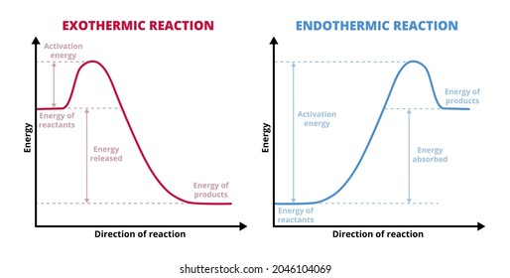
B. 
C. 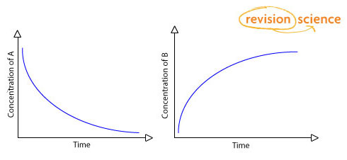
D. 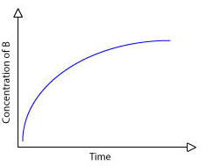
ANSWER: A
Which of the following reaction is endothermic?
A. Combustion
B. Haber’s process
C. Formation of water
D. Decomposition of water
ANSWER: D
Which statement is not true regarding endothermic reactions
A. They have negative enthalpy
B. Heat is taken in by the system
C. Temperature of the system falls below the room temperature
D. None
ANSWER: A
The spontaneous endothermic reaction is:
A. N2(g) + O2(g) 2NO2(g)
B. H2O(l) → H2O(g)
C. 2H2O(l) → H2(g) + O2
D. NaOH(aq) + HCl(aq) → H2O(l)
ANSWER: B
Which of the following energy profile diagrams best shows an exdothermic reaction?

A. 
B. 
C. 
D. 
ANSWER: B
A process that moves form non equilibrium state to equilibrium state on its own is called:
A. Spontaneous reaction
B. Endothermic reaction
C. Non spontaneous reaction
D. Exothermic reaction
ANSWER: D

The total energy of the system and its surroundings:
A. Increases with time
B. May increase or decrease
C. Decreases with time
D. Always remains constant
ANSWER: D

